Insiights from the analysis
Drawing insights from the correlation between features..
- Fare and Pclass are negatively correlated (with a Pearson’s correlation coefficient of -0.55) ; Obviously, higher fares imply better better ticket classes (lower the class number) and vice versa.
- Pclass and the target feature are moderately negatively correlated (-0.34) implying better the ticket class, higher the chance of survival.
- A similar pattern can be observed with the features Parch, SibSp and Age; Both the features, Parch and SibSp are very slightly correlated with all the features except Age feature, and both have a negative correlation (-0.19 and -0.31 respectively) with Age ; Lower the age, more the number of family accompanying the passenger
- SibSp and Parch features are positively correlated which are both indicative of the number of family members accompanying passenger
- PClass and Age are negatively correlated (-0.37) implying higher the age, better the ticket class.

Age : Contains 177 nan values out of 891 entries. Imputed with median gave best results.
Embarked : Contains 2 nan values. Imputed with mode of existing data.
Cabin : 687 out of 891 Cabin entries are nans, i.e. more than 50 percent of the total data exists as missing data or Nans so assumed its better to derive other features from this feature.
Now, printing the correlation heatmap after handling missing data and converting categorical strings to encodings (0,1,2..)..
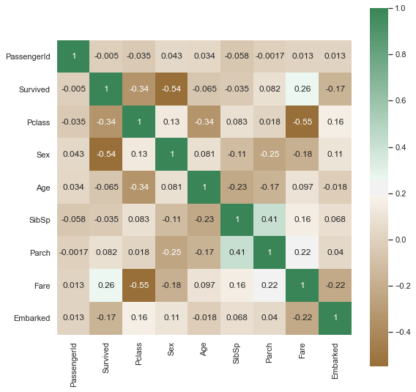
- Embarked also has slight correlation with the target variable (-0.17), the port at which the ship was boarded by the passengers did determine their chance of survival
- Sex is also highly correlated with the target variable (-0.54), indicating the passenger’s gender had a high effect on their chance of survival
- Embarked and Fare of the passengers are negatively correlated (-0.22); obviously, fare depends on the port a passenger boards the ship from.
- Embarked and Sex also seem slightly correlated (0.11) indicating the port the passenger boarded from was dependent on the gender of the passenger; Embarked and Pclass are also correlated (0.16) indicating a 1st class passenger probably boarded at a different port than a 3rd class passenger.
- Sex and Fare, Sex and Parch, SibSp, Sex and Pclass all seem slightly correlated (-0.18, -0.25, -0.11, 0.13 respectively); i.e the fare the passenger paid, the family aboard, and the class of the ticket was seem slightly dependent on the gender of the passenger.

